  - 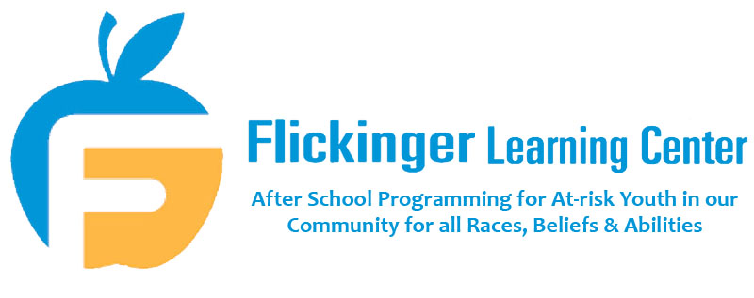
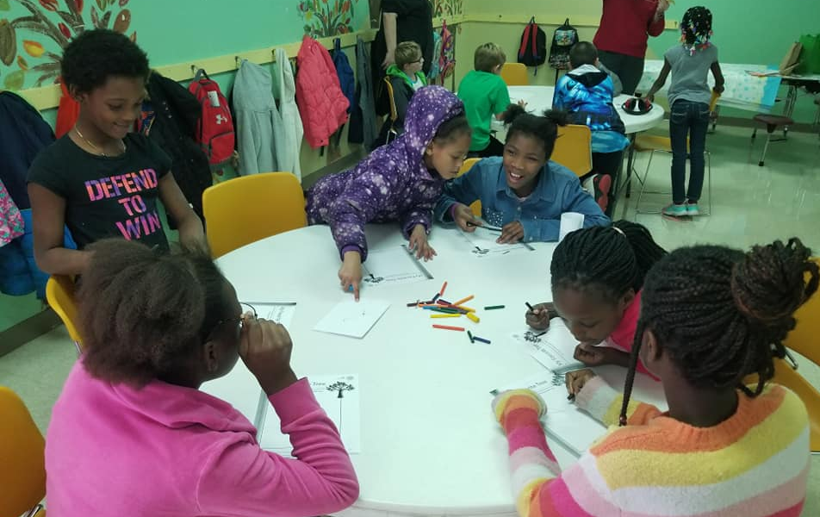
Annual Report
Prepared for July 2019 Board Meeting

TAble of
Contents
FlICKINGER LEARNING CENTER ANNUAL REPORT
Goals 1
Current Ongoing Programs 2
Parent Survey Results January 2019 3
Child Survey Results January 2019 4
Ethnicity Data 5
A Community Working Together 6-10
What's New This Year 11-14
In With the New, and Out With the Old 14-16

Current Board of Directors

Brenda White – 309-791-1112
Retired
whitejb@machlink.com
(President)
Melanie Strong – 563-554-3424
CBI Bank and Trust
Melanie.Strong@cbibt.com
(Vice President & Board Secretary)
Tamera Paul - 563-299-5737
Grain Processing
tamera_paul@grainprocessing.com
(Treasurer)
Amber Hardin - 309-781-1749
AllSteel
HardinA@allsteeloffice.com
Karen Mills - 563-260-5671
Monsanto
karen.l.mills@monsanto.com
Dale Sweere - 563-299-7920
Stanley Consultants
Sweeredale@stanleygroup.com
Jessi Freers - 563-506-3229
Muscatine Community School District
jessi.freers@mcsdonline.org
Sonia Baars - 563-506-1887
Muscatine Community School District
sonia.baars@mcsdonline.org
Chad Adams – 563-263-6461
Hy-Vee Mainstreet
7060Director@hy-vee.com
Carol Ward - 563-607-0743
Retired Teacher
cwrd50@hotmail.com
Danni Zumwalt - 563-506-3938
FLC Executive Director
danni@flickingerlearning.org

Goals
Our goal is to dramatically increase the engagement of children in the Muscatine Community School District. By taking action now, we expect an immediate and long-lasting impact in these children’s lives and futures.

- Maintain our current growth of approximately 10% faster in reading
- Increase family involvement and available educational opportunities
- Increase community awareness and involvement
- Increase attendance and engagement for students in the school environment
- Decrease behavioral referrals

MISSION STATEMENT
It is the purpose of Flickinger Learning Center to provide educational opportunities for learners of all races, beliefs, and abilities to build stronger individuals and a healthier community.

Current ongoing programs
- We offer academic After-School Programs at four sites - including our main site located at 413 Mulberry Ave, Sunset Park, McKinley School, and Madison School. We have a program cap of one hundred students across these four sites.
- We partner with United Way of Muscatine and a private donor to provide healthy snacks for the children every day of programming.
- Families Inc, Musser Public Library, UnityPoint New Horizons Drug and Alcohol Prevention Services, Hy-Vee Mainstreet, Ric Smith’s Children’s Choir, and Judy B provide special programming at our after-school program. These special programs help to enrich our children by providing specialty classes and services to better serve the whole child.
- Nancy Dew and Hy-Vee Mainstreet work to provide a Hy-Vee One Step Grant, allowing us to have an ongoing garden that helps teach the children about planting, growing, and harvesting their own foods. It also helps teach and encourage healthy eating.

"Alone we can do so little; together we can do so much." – Helen Keller

Parent Survey Results January 2019
Parent Surveys were initiated in 2015, and are repeated annually. We survey all parents at each site in order to gauge how parents view their children’s progress.
Total number of responses for all programs - 37
Do you feel that the afterschool program is a safe place for your child to be?
100% answered yes
Has your child become a better reader since starting the afterschool program?
92% answered yes, 8% answered no
Does your child complete his/her homework during the afterschool program?
86% answered yes, 6% answered no, 8% answered not applicable
Is your child doing better at school since starting the afterschool program?
97% answered yes, 3% answered no
Do you qualify for Free or Reduced Lunch through the Muscatine Community School District?
81% answered yes, 16% answered no, 3% answered unsure
Child Survey Results 2019
We also survey the kids every year, because their thoughts are important too - after all, they’re the reason we’re here! When asked what they liked about the program, here is what some of our kids had to say:
“We get to have fun, learn, and play Sumdog!”
“That we get to play with our friends.”
“Getting on Sumdog, and being nice to people and kind.”
“That we do AR tests and actually read and get better at it, and I’m getting better at math.”
“It’s special. I love when I get to do stuff.”
“They help you learn!”
“That we do math! My favorite subject!”
“All of it.”
“Technology and snack.”
“I like the workers, and playing downstairs.”
“When we use the computer.”
“Learning!”
“When Miss Dana comes!”
“It is fun.”
“I like it when we eat snack.”
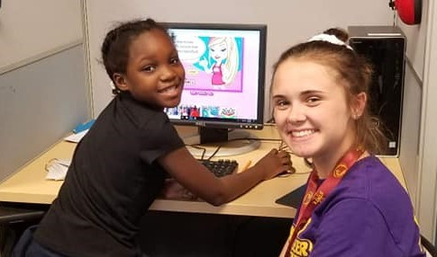
Ethnicity Breakdown May 2019
Main Site:
White 30%
Black or African American 50%
Hispanic/Latino 20%
Madison:
White 50%
Black or African American 1%
Hispanic/Latino 48%
Asian 1%
McKinley:
White 56%
Hispanic/Latino 44%
Sunset:
White 60%
Black or African American 30%
Hispanic/Latino 20%

All Programs:
White 43%
Black or African American 27%
Hispanic/Latino 29%
Asian 1%

A community Working Together
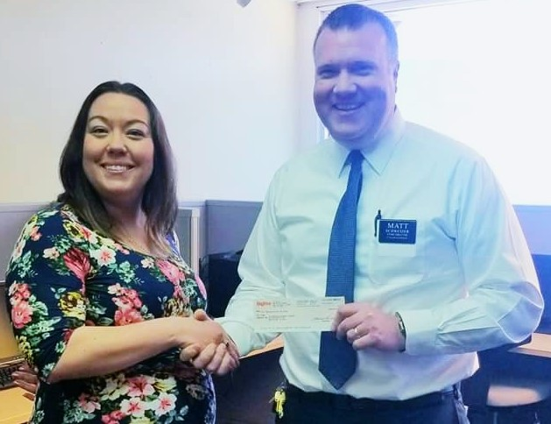

Flickinger Learning Center programming is provided free of charge in order to ensure that the children who need our help will never face financial barriers when it comes to academic enrichment. We rely on support from the community to keep it that way.

In the past year, we have been very fortunate to receive grants and donations from The United Way, The Community Foundation of Greater Muscatine, The Howe Foundation, Bayer, HNI Charitable Trust, Kent Corporation, Zachry, New Hope Foundation, and Hy-Vee Mainstreet, in addition to many local businesses and private donors. Thanks to board member Matt Schweizer, it is a generous donation such as this from Hy-Vee that will allow us to provide summer programming this year!

Flickinger has also been the lucky beneficiary of a number of non-monetary donations. Muscatine Newcomers’ and Friends’ Club reached out to us via social media, letting us know we had been chosen as their Charity of the Month for April! President Nancy Todd brought us a wealth of cleaning supplies, tissues, plastic silverware, and miscellaneous paper goods for use at our main site – small items like these make the biggest difference in our daily operations.

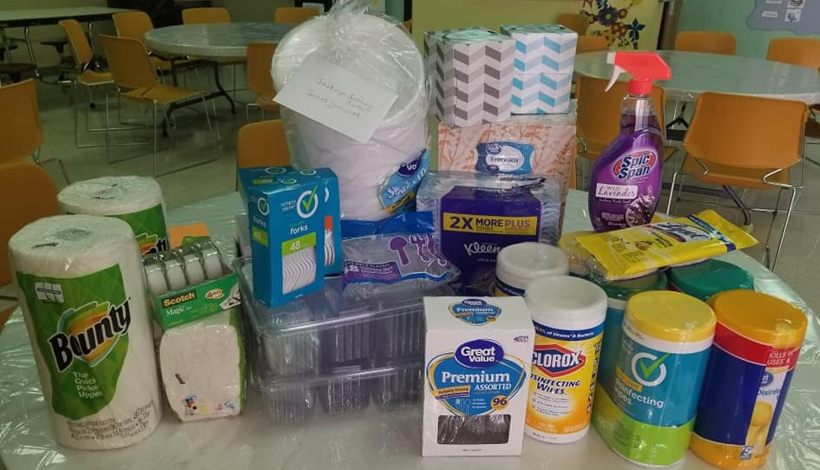

The community of Muscatine has been kind enough to donate new and gently used books to our continually growing library, many of them brought to us by MCSA. Board member Brenda White donated a Wii Fit for our basement recreation area, and the Young Professionals Network gifted us with a cache of office supplies and craft items for the kids – one of their favorite things to do during downstairs free time!

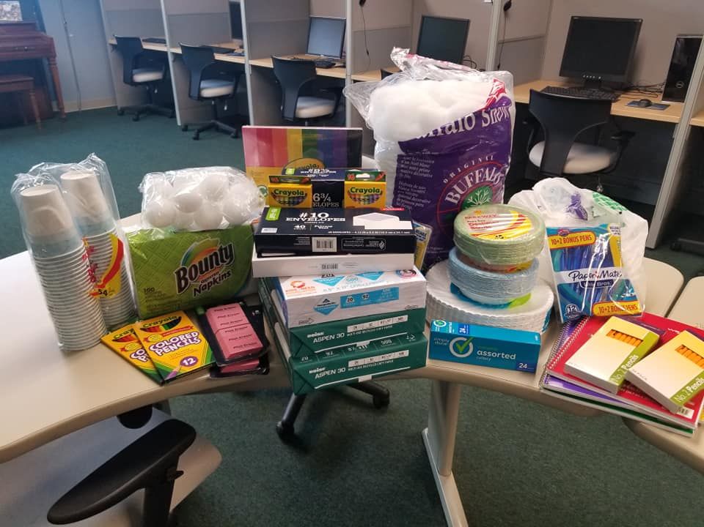
Our annual Trivia Night Fundraiser was held in February, and we were once again overwhelmed with community support from local businesses and sponsors for the event. Silent Auction items, prizes, and time were donated by Ardon Creek, A Guy and A Grill, CBI Bank & Trust, Community Bank & Trust, Happy Joes, Lifetime Dentistry, Paul Brooks, Mary Kirchner, Riots and Rebelle’s Salon, Salon Incognito, HON Company, Coffee Belt, Pack-N-Ship, Kenda Kist Jewelry, Fresh Vintage, and Sal Vitale’s. The following businesses were sponsors of the event: Kent Corporation, Lifetime Dentistry, Paul Brooks, Riots and Rebelle’s, Team Staffing Solutions, HON Company, First National Bank, Bayer, and N&S Heating and Cooling. We had a great turnout raised over $5,000 because of the amazing support we received!
Sometimes what people donate can scarcely be measured in dollars and cents. We have a very dedicated group of volunteers that come to the centers daily to help with reading, homework, listening to a story, playing a game, working on art projects, or even just helping with supplies. The Muscatine High School Girls’ Soccer Team does one volunteer day every season, and this year they chose to spend that day with us at our Main Site. We had over 30 girls here, along with their coaches, working on prepping art supplies for summer program projects, putting together end of the year supply bags for the kids to take home, reading with the kids, and so much more. Needless to say, it was a crowded day at FLC, but they were a huge help and such a joy to have on-site! Our kids had a great time, and programming was wrapped up with a dance-off between our kids and the soccer team, what a blast!

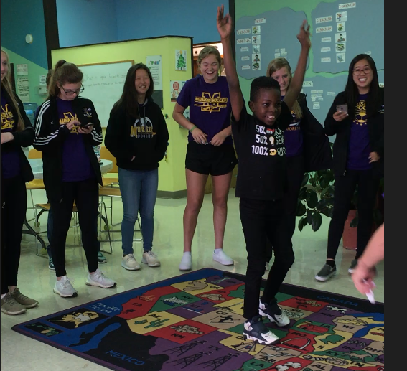

"It is literally true that you can succeed best and quickest by helping others to succeed." – Napoleon Hill

What's New this year!
FLC Main Site’s basement renovation was completed in October 2018 with a final cost of $59,942.57, and we were finally able to utilize that space during programming. Our kids go through three stations throughout a regular programming day (reading, testing, and activity/homework), and if they successfully complete all three stations without incident, their final station is downstairs free time. It has been great for us to have an incentive to offer them, and to give them time to just be kids – a lot of them don’t have that luxury at home. They have so much fun in the new space, and some of them would probably say it’s their favorite thing about Flickinger!
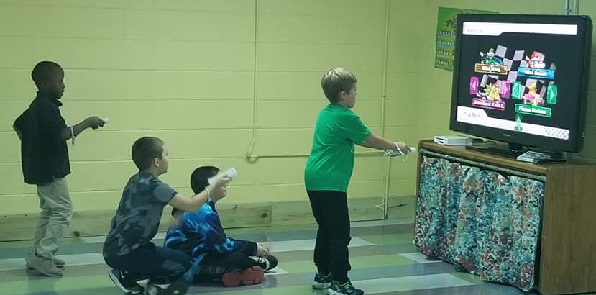

Basement Repair Detail
Contractor | $41,540.00
Plumbing | $1,092.00
Electrical | $570.00
Flooring | $3876.45
Abatement | $1,601.45
Supplies | $12,975.21
 | $59,942.57

During the 2018-2019 program year, we operated four sites across Muscatine - our Main Site on Mulberry Avenue, Madison School, McKinley School, and Sunset Park. The Main Site, along with Madison and McKinley, was paid for with funds from Flickinger Learning Center, while Sunset Park costs were covered by the City of Muscatine. We learned that the City of Muscatine will no longer be covering the costs of Sunset Park programming, and made the decision to absorb the funding of that site into Flickinger's budget for the upcoming program year. It is paramount to our mission that no child goes without our services due to financial restrictions, and we feel that the demographic served at Sunset Park will be vastly underserved without continuation of programming.
Also beginning this program year, Flickinger entered into partnership with River Bend Food Bank to open a mobile pantry at our Main Site. We now have a food cabinet located onsite that we keep stocked with donations picked up from River Bend Food Bank's warehouse location in Davenport, offering a variety of canned vegetables, beans, and soups, along with healthy snacks like granola bars and cereal. The kids and their parents are welcome to take anything they wish from the pantry, no questions asked, something we find invaluable for our kids that are dealing with food insecurity and single or no income households. In our continued efforts to serve the whole child, we want them to be able to focus on their studies and growth rather than worry where their next meal will come from. Since the start of this program, we have served an average of 60 individuals every month.
On top of our food pantry, we have initiated a clothing closet for the children that need it. A lot of parents we work with do not have the means to provide warm clothing for their kids in the winter months, so we have procured clothing donations in order to provide them with socks, snow boots and pants, winter coats, and hats and mittens. The closet also contains shirts, pants, bookbags, and other miscellaneous clothing items the children might need.
Flickinger Learning Center also made the jump to join the Greater Muscatine Chamber of Commerce and Industry. Executive Director Danni Zumwalt and Assistant Executive Director Mindy Ross attended a Business Afterhours Event for newcomers, where they were able to meet other Chamber members and tell them about our organization. We partnered with Kiwanis of Muscatine and the Chamber to host a Wake-Up Wednesday breakfast event at our Main Site, allowing us to give tours and raise awareness for what we do!
in with the new, and out with the old
We are currently in need of, and working on securing funding for a new furnace and duct work to replace our forty-three-year-old system. It is of utmost importance that we provide the best possible environment for these children, and being able to assist them throughout the entire year is vital to that success. At some point, our tired old furnace will stop heating the building altogether, and we fear what that will mean for the children during the winter months. Many of them walk home from school and are living in poor conditions, and we genuinely want to give them a warm place to come "home" to. Dan Moody of Dan's Heating and Cooling has cut us a deal and will replace our old system for $5000, which may qualify for a $700 Alliant Rebate. Savings right out of the gate! With the help of our awesome donors, we were able to secure funding to cover this cost. The work will be completed by July 2019!
Safety is something we prioritize at Flickinger, and part of that includes monitoring activity with security cameras. We want to make sure that if there are any behavioral issues with our students, we are able to stop them before they escalate and/or be able to clearly see what happened in order to explain any occurrences to parents. It is also helpful to decrease any parking lot crime that may occur from passersby, something that has been an ongoing issue for us given the location of the Main Site.
This year, we were finally able to replace our obsolete security system with brand new cameras! After careful research, the decision was made to go with Integrated Technology Partners in Wilton, IA, who were able to give us a new security monitor system for $6016.54. With this new system, Danni, Mindy, and Site Coordinator for our Main Site, Kelly, are able to watch all 10 cameras from their computers, and easily playback footage from any one of them. No more guesswork rewinds! We are also now able to clearly see what is going on outside both in front of and behind our building, something that is crucial to the safety of our staff and the children we serve.
It has been a great year for FLC and we are all looking forward to whatever the next year will bring!

"None of us, including me, ever do great things. But we can all do small things, with great love, and together we can do something wonderful." – Mother Teresa

