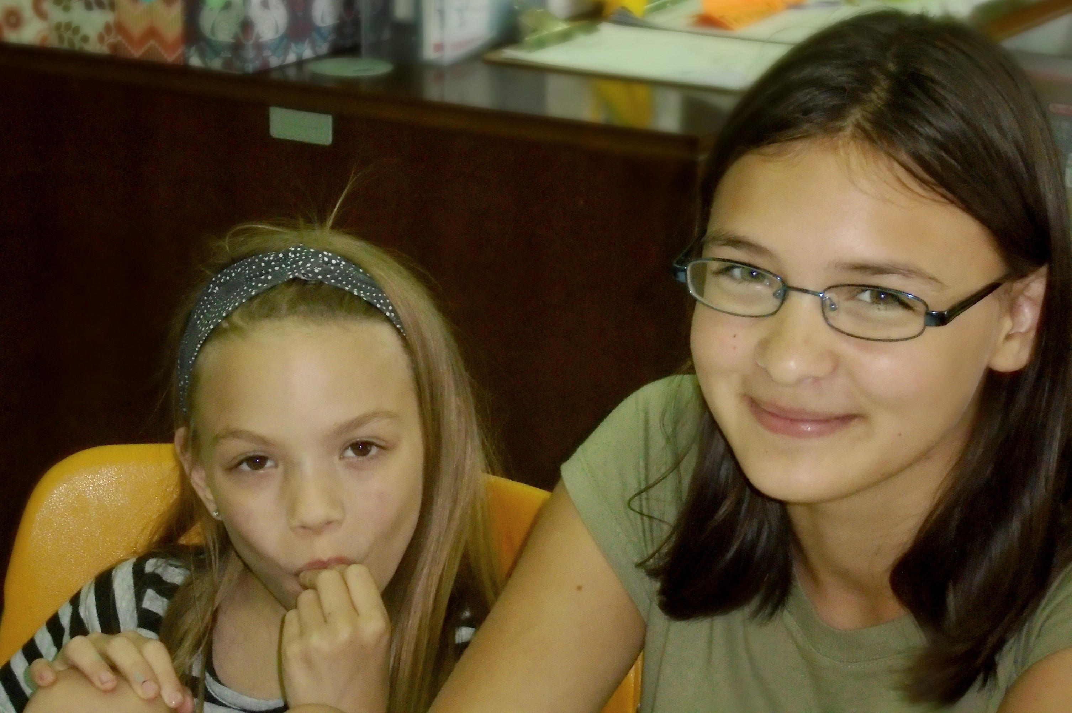  Help Wanted!  Do You Want to make a difference in the life of a child?  Flickinger Learning Center runs an academic after-school program for area at-risk or underserved children in grades K-5. We do not charge for our programming. We rely heavily on our volunteers to give our children the guidance and attention that they deserve while keeping costs low.  Our volunteers do a variety of things to support our mission. They read with children in groups or one on one, help with math and writing, Model good social skills, and provide guidance and nurturing. We even have volunteers that come and share their passion for art, music, writing, physical fitness etc. with the kids.  Not interested in working directly with the children? We also need assistance with general maintenance, cataloguing books, putting together projects, painting, assisting with fundraisers, and cleaning.  To RSVP, or if you are interested but cannot attend the event: Contact kimberly@flickingerlearning.com or 563-288-9000  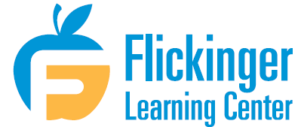 | Volunteer Open House:  September 14, 2018 6:30pm  Please use our 5th St. parking lot located across from Hy-Vee Mainstreet  ────  Take a tour and learn more about our programs  ────  Find out what we achieved in the 2017/2018 program year  ────  Hear directly from returning volunteers  ────  Dinner will be provided  Flickinger learning Center  413 Mulberry Ave.  Muscatine, IA 52761  (563) 288-9000  https://flickingerlearning.org/

